

Ambassador – Documentum
Adapter Requirements
(HR New Horizon)

Document revision history
Date | Version # | Changed By | Change Description | Status  [Draft,  Submitted to PMO HR2U,  Submitted for approval,  Signed off]
28-Apr-2006 | DRAFT (0.1) |  | Initial release for Transware review | DRAFT
13-May-2006 | DRAFT (0.2) | V.Graf | Added relation detail.  Added cancel job requirement | DRAFT

Glossary
Term | Definition
HR | Human Ressources
KB | Knowledge Base
NH | New Horizon
[courier font] | Any word or expression written in this font refers to Documentum technical terms. Refer to EMC documentation

Table of Contents
1. Introduction 3
1.1. Goal of the document 3
1.2. Scope / Responsibilities 3
2. Requirements 4
2.1. Business requirements 4
2.1.1. (1) Master document 4
2.1.2. (2) Menu item 4
2.1.3. (3) Translation panel 4
2.1.4. (4) Update of the Document 5
2.1.5. (5) Transfer to Ambassador 5
2.1.6. (6) Translation 5
2.1.7. (7) Return to Documentum 5
2.1.8. Multiple language translation 5
3. Technical requirements 5
3.1. Introduction 5
3.1.1. Component Location 6
3.1.2. Configuration and Component Scope 6
3.2. Requirements 6
3.2.1. Translation Relation 9

Introduction

Goal of the document
This document provides a summary of both business and technical requirements towards the integration of the translation process taking place in the knowledge base for HR / New Horizon project (also referred as the Documentum solution for HR / NH Project).

Scope / Responsibilities
PMI IKM is in charge of supporting the KB solution to PMI HR. Within this solution, Transware is itself in charge of providing both translation facilities with the Ambassador Product and translation integration into the Knowledge Base itself (Documentum solution).
The following figure illustrates those responsibilities.

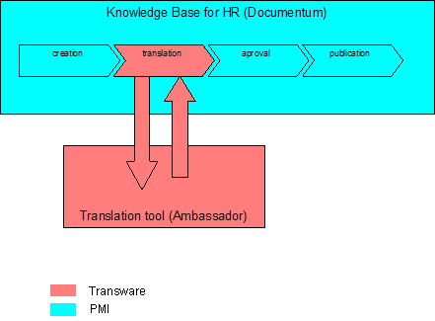

Requirements

Business requirements
The following figure details the translation process in terms of functionalities. Responsibilities are further marked in blue / red.

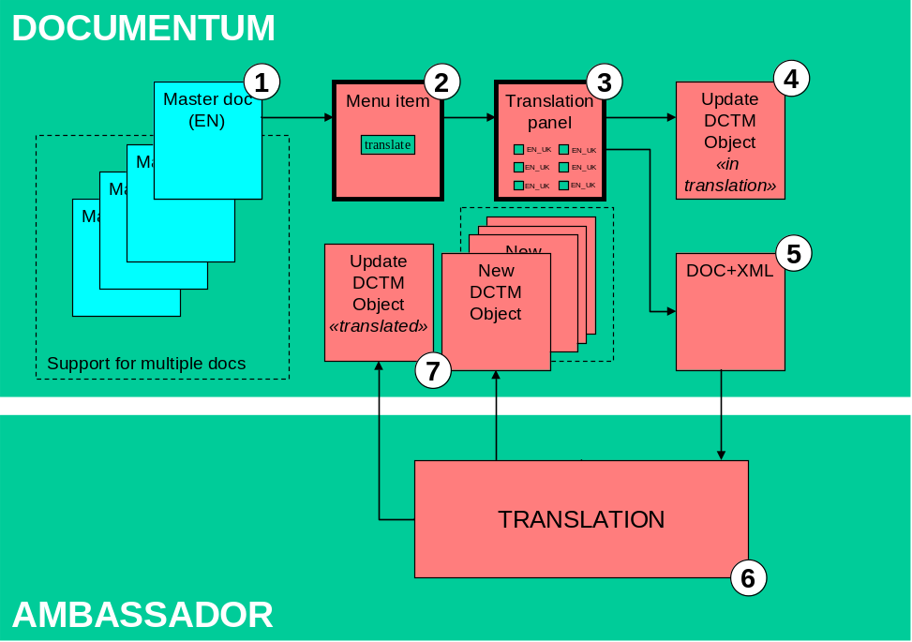

(1) Master document
Any translation is based on a master English version (source) located in and provided by Documentum.

(2) Menu item
The translation process is initiated by the user that selects the item(s) to translate and calls the translation function with a new menu item.

The possibility to submit a group or a set of documents into the translation process is also needed.

(3) Translation panel
The translation options (language/country) are selected by the user with an ad hoc panel (check boxes). The user is able to target language(s) either individually or by preconfigured grouping (e.g. PMI global, EEMA, EU, etc).

Some documents will have “audience” attributes that should be used to drive the selection process (e.g. pre-select language fields). For example, according to geographical taxonomy and content type, a policy for Switzerland shall be translated into French/Switzerland and German/Switzerland.

In the case that multiple documents are selected, they should all follow same translation option. Conflicts within the “audience” attributes should be flagged as a warning.

(4) Update of the Document
The Documentum master document is changed to the state “in translation” (or any other change to MetaData).

(5) Transfer to Ambassador
The document to be translated and its MetaData packed into XML are transferred to Ambassador.

The determination of what MetaData attributes are translated must be defined in Documentum in a configurable way.

(6) Translation
The translation process in Ambassador itself is here intentionally considered as a black box and thus not further detailed.

(7) Return to Documentum
Upon successful translation, an attribute on the master English document (e.g. Multi-value attribute called “Translation”) should be appended with the Language.

The translated document is created in Documentum and associated to the original.

In the case that multiple documents were first selected, there is no requirement for these to have synchronized delivery to Documentum (i.e. Completed Translation jobs should not be held back)

Multiple language translation
If a single master document is submitted for translation into n different languages, the delivery of the translated content back to Documentum will concern n different documents.

Technical requirements

Introduction
The Translation component must be delivered as a WebTop WDK based custom component.
For reference, development of such components is fully covered in the EMC WDK Fundamentals and WDK Advanced courses. The audience should be familiar with WDK components development as well as the techniques involved for deployment. Thorough knowledge of core Documentum concepts is also a pre-requisite.

- The target system is WebTop 5.3 SP2 and no earlier version need to be supported.
- Localization of the component is not required in the first version (English is the main language of the interface).

Component Location
As per EMC recommendation, the customization of WebTop needs to be defined in the dedicated <root>/webtop/custom directory.

Graphically, the following applies:
- The Translation component should be available via a dedicated WebTop menu item (i.e. a new menu).
- The menu item should be available from both the classic and streamline view of Webtop.
- The menu item should be enabled only at the document level (or when a document is selected). Similar to the View menu item in WebTop.

Configuration and Component Scope
By configuration it is meant: any modification which is external to the component itself, that can be modified without downtime and/or code change. This type of tasks is typically under the responsibility of a system administrator.

- The component should have the application scope set to WebTop.
- Type scope restriction of the component should not be used.
- The translation component menu item is technically available for any documents in any folder (e.g. the configuration should not be based on a “hard-coded” folder structure sequence, see below for more details).
- Configuration of the component should let PMI define (see below for details):
- List of available languages
- List of pre-selected languages

Requirements
# | Description | Comments
 | When a document is sent for translation, some of its metadata need to be sent along for translation as well. The technique used to send the attributes is let to Transware to define (e.g. XML).  However, PMI requires the ability to configure the subset of attributes to be sent: the subset of attributes is defined at the doctype and folder level (note: folder refers docbase/cabinet/folder). This means that a mapping of  Doctype+folder_path ←→ attributes list  must be possible.  Example:  pmi_policy+<docbase>/HR/PMI ←→ description, category  Note: A mimimum requirement is the doctype and docbase. | See R12 below for mapping mechanism
- a | The list of available languages that a user can select for translation should be configurable at the doctype and folder level. The mechanism is similar to R1 above.  The list of available language will always be a subset of the profile available in Ambassador. | See R12 below for mapping mechanism
 | The languages which are pre-checked in the language selection panel should be derived from attributes at the document level.  This means that a specific attribute of the document object will be used to specify the languages to be pre-checked. This attribute will contain a code which is mapped to a list of languages.  Example:  - A document has its attribute pmi_planguages=G27  - The code G27 is mapped to several language pairs (ex: EN_CN, EN_FR, EN_DE, etc)  - The language selection panel has the languages Chinese, French, German, etc pre-checked. | See R12 below for mapping mechanism
In order to support security, change management across our systems landscape (DEV, QA, PROD) the system account scope needs to be defined. Therefore, when a translated document is sent back to the system, a specific system account will be used to guarantee sufficient access and privileges to wherever the document is saved.
This means that the component must be able to be configured with such an account (user_name, password, etc.). A minimum security should be implemented onto this account definition (e.g. encryption). This account will be set by a system administrator and its scope is the WebTop instance (i.e. webapp instance on a server).
The Translation Component should be role aware. This means that the notion of role which can be used in Documentum WebTop to “customize” the GUI should be used to show/hide the menu item to the end users.
Any WDK/WebTop component obeys the role model of Documentum. This is defined in the configuration XML file.
A multi value attribute is being populated when the document is successfully sent to Ambassador with the Ambassador Job# for each of the language pairs requested.

Example:
- A document is sent to translation with Polish and Dutch selected
- When the jobs are successfully created in Ambassador, the attribute pmi_translation is filled in with the two job ids: lets say: pmi_translation=00034, 00035 (one for Polish and one for Dutch)
This multi value attribute is updated with the language of the finished jobs as they come back to Documentum.

Example (following from above):
- When the Polish translation is sent back to Documentum, the pmi_translation is updated: pmi_translation=Polish translated, 00035
 | When a document is sent successfully to Ambassador, the document is checked-out (by the application account). This means that the document cannot be modified anymore.
 | When the last translation is successfully saved back in Documentum, the document is checked-in. The version of the object should remain the same.
 | When a translation is saved back in Documentum, a copy of the master object should be created and the translated content should be associated with that copy. Several meta-data needs to be overridden to reflect the translation:  - Translated attributes are set  - Language is set  Also, a relation with the master document must be created.  For more details on relation see below | The set of attributes to be overridden is to be validated.
A document (for which the translation component is available) cannot be sent to translation whenever one or more of the following conditions is met:
- Document is checked-out
- The Document is part of an active workflow
In this case the translation panel will display the correct warning.
 | When a configuration requires a rule with mapping, this supporting information/data should be stored using a dedicated doctype with no supertype. This allows full access to the data from within Documentum product and granular security.  Example:  If we need a mapping for the attribute pmi_planguage where a code is mapped to a list of languages, a new doctype is created with two new attributes: code and value. Then, for each code/languages list we need to manage, we create a new object of this type to store it.  This is very similar to using Documentum registered tables. | This requirement is subject to discussion as other mechanisms are possible as well.
 | For the sake of simplicity and for the first version of the component, error handling at the component level does not need to do any corrective action but should be “bullet proof” in terms of document integrity (i.e. if the component catches an error, the document is not modified).
 | A cancel job mechanism (or process) should be proposed. On the Documentum side, it would simply revert the check-out and the attributes that stores the requested translation revert back to empty.

Translation Relation
The relation between a master document and its translations will be done using the document relation mechanism. User-defined Relationships are described in the document Content_Server_53_SP1_object_ref.pdf (note: also applies to SP2) on page 34. Same document describes the object model of the dm_relation_type and dm_relation objects.

The figure below illustrates the translation process on the relation point of view:
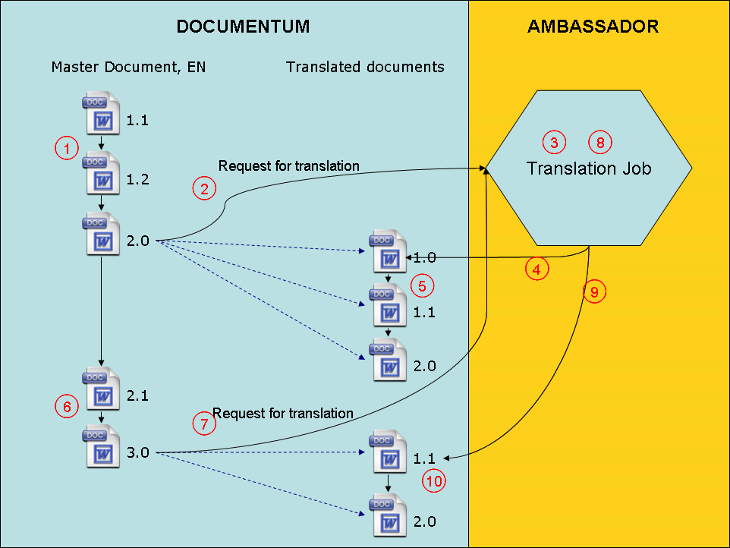
Figure 1

Step | Description
1 | The master document is being worked on until it reaches the state where it is “FINAL” (on the figure marked as Version 2.0)
2 | The Ambassador adapter is used to send the translation job request
3 | Ambassador is used to create the appropriate translation
4 | Ambassador sends the translation back into Documentum and creates the relation between the Master and the translated version.
5 | The translated version is going through modifications, the relation is kept with the master
6 | When the master is modified, the relation is not kept (as the translation are no more in line with the modified version of the master. However, the Version 2.0 of the master still has the relation with the translation 2.0)
7 | When the master reaches a final state again, a new request for translation is made to Ambassador
8 | Ambassador is used to create the translation
9 | Ambassador puts the translation back into Documentum as a new object (i.e the new translation is not a version of the previous translations)
10 | When the translation if modified the relation is kept.

To support the process above, relation needs to be implemented the correct way. The definition of the relation type will be done by PMI. Ambassador only needs to know the relation type name and use it to create a new relation.

The relation will follow the following:
Attribute | Value
Parent_id | The object id of the master document
Child_id | The object id of the new document holding the translation
Child_label | CURRENT (must be this value!)
relation_name | pmi_translation (must be this value, should be configurable)
Description | TBD, optional attribute for information (char255)
Effective_date | Timestamp of the operation

Exemple of creating the relation (in DQL) would be:
create dm_relation object
set parent_id = '….',
set child_id = '…',
set child_label = 'CURRENT',
set relation_name = 'pmi_tranlsation',
set description = 'xxxxx',
set effective_date = DATE('13/06/2006','dd/mm/yyyy')

For information, the dm_relation_type created by PMI will be similar to:
create dm_relation_type object
set child_parent_label = 'translation of',
set parent_child_label = 'master of',
set description = 'Manage master to translation relation',
set parent_type = 'pmi_doc',
set child_type = 'pmi_doc',
set direction_kind = 0,
set integrity_kind = 0,
set permanent_link = FALSE,
set copy_child = 0,
set relation_name = 'pmi_translation',
set security_type = 'PARENT'

